Sri Lanka Institute of Information

Technology



Lab Submission

<Lab sheet No 08>

**<IT24102493>**

**<Bandara DKAS>**

**Probability and Statistic | IT2120**

B.Sc. (Hons) in Information Technology

Exercise

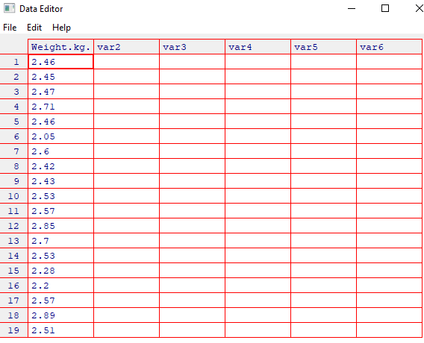

1. 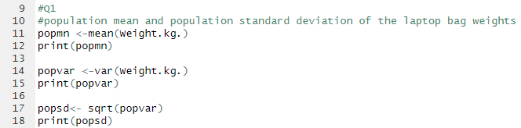 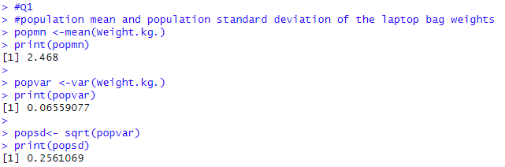

1. 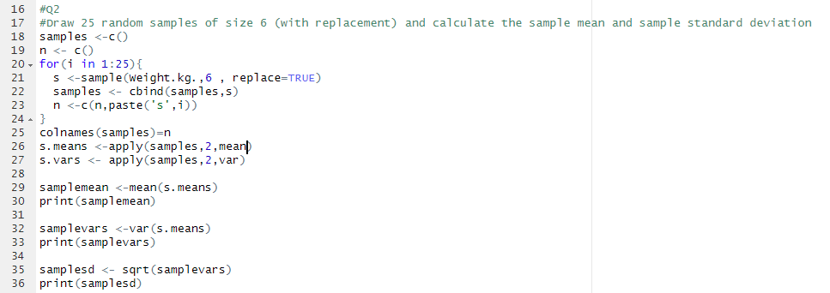

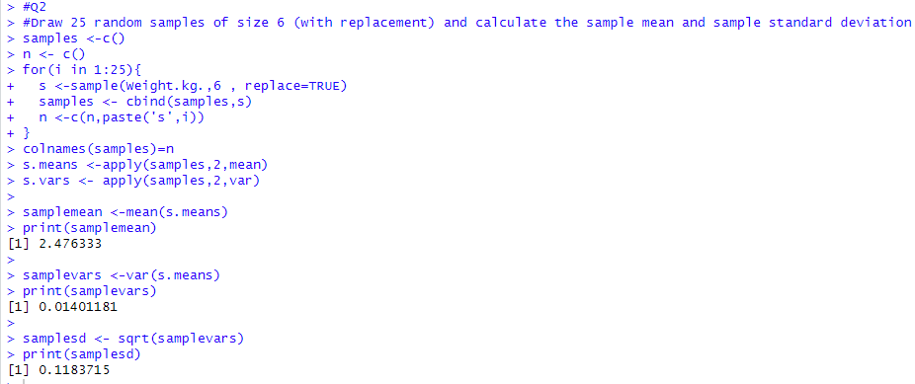3) 